

**### Step 1: The Need for Speed**

1. Upload the following file of the system speeds around the time of the attack.

**- [Speed Test File] (resources/server_speedtest.csv)**

2. Using the `eval` command, create a field called `ratio` that shows the ratio between the upload and download speeds. - Hint: The format for creating a ratio is: `| new_field_name new_field_name = 'fieldA' / 'fieldB'`

**Query Command:** **source="server_speedtest.csv" | eval ratio = 'UPLOAD_MEGABITS' / 'DOWNLOAD_MEGABITS'**

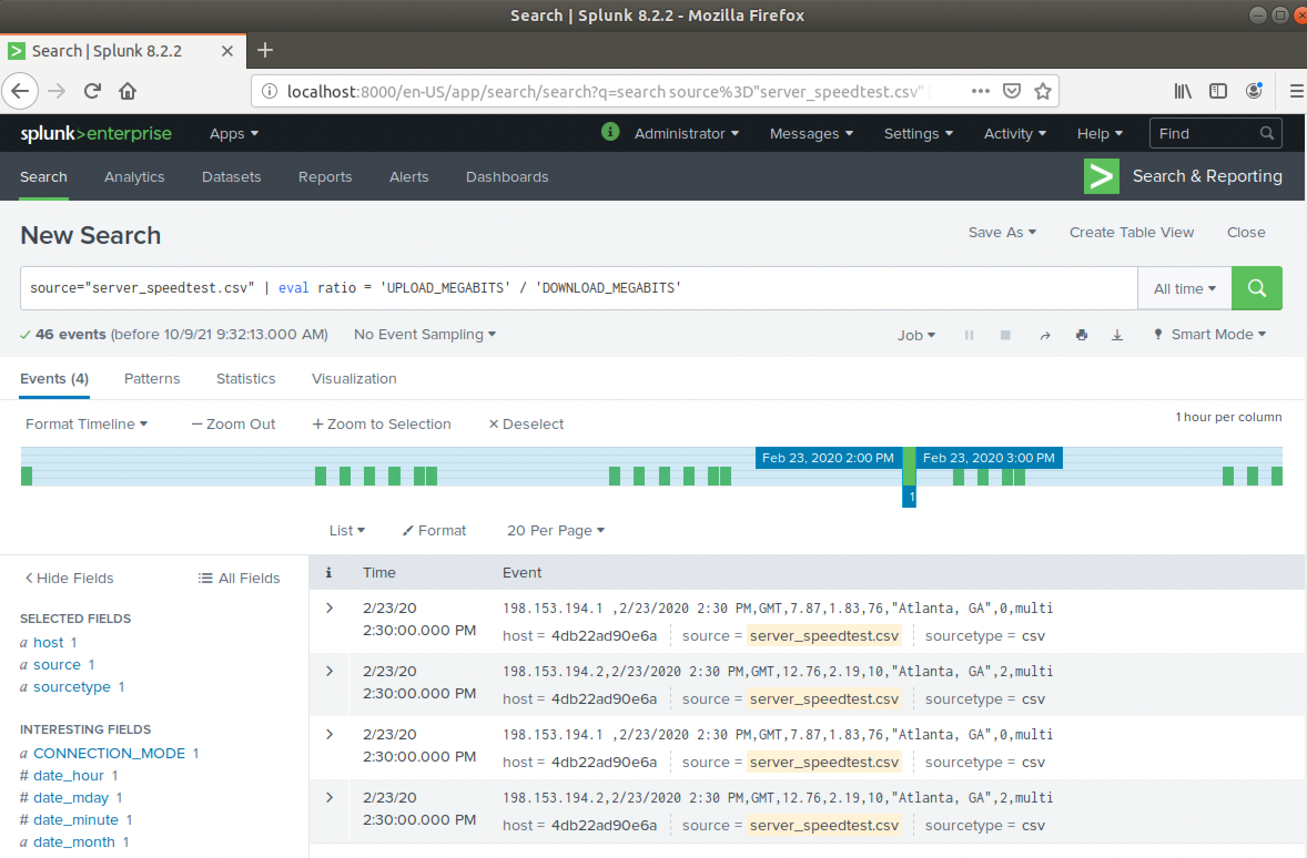

3. Create a report using the Splunk's `table` command to display the following fields in a statistics report:

- `_time`

- `IP_ADDRESS`

- `DOWNLOAD_MEGABITS`

- `UPLOAD_MEGABITS`

- `ratio`

Hint: Use the following format when for the `table` command: `| table fieldA fieldB fieldC`

**Query Command:** source="server_speedtest.csv" | eval ratio = 'UPLOAD_MEGABITS' / 'DOWNLOAD_MEGABITS' | table _time IP _ADDRESS DOWNLOAD_MEGABITS UPLOAD_MEGABITS ratio



4. Answer the following questions:

- Based on the report created, what is the approximate date and time of the attack?

**Answer: -** Based on the speed test report, the attack started at Feb 23, 2020 14:30 and during that time the download speed dropped dramatically down from 105.91Mbps to 7.87 Mbps.

- How long did it take your systems to recover?

**Answer: -** Well it lasted till Feb 23 2020 at 23:30 and that time the speed returned to normal over 122.91 Mbps and the systems recovered 23:30 and operation back to normal, so almost it took about 9 hours.

Submit a screen shot of your report and the answer to the questions above.

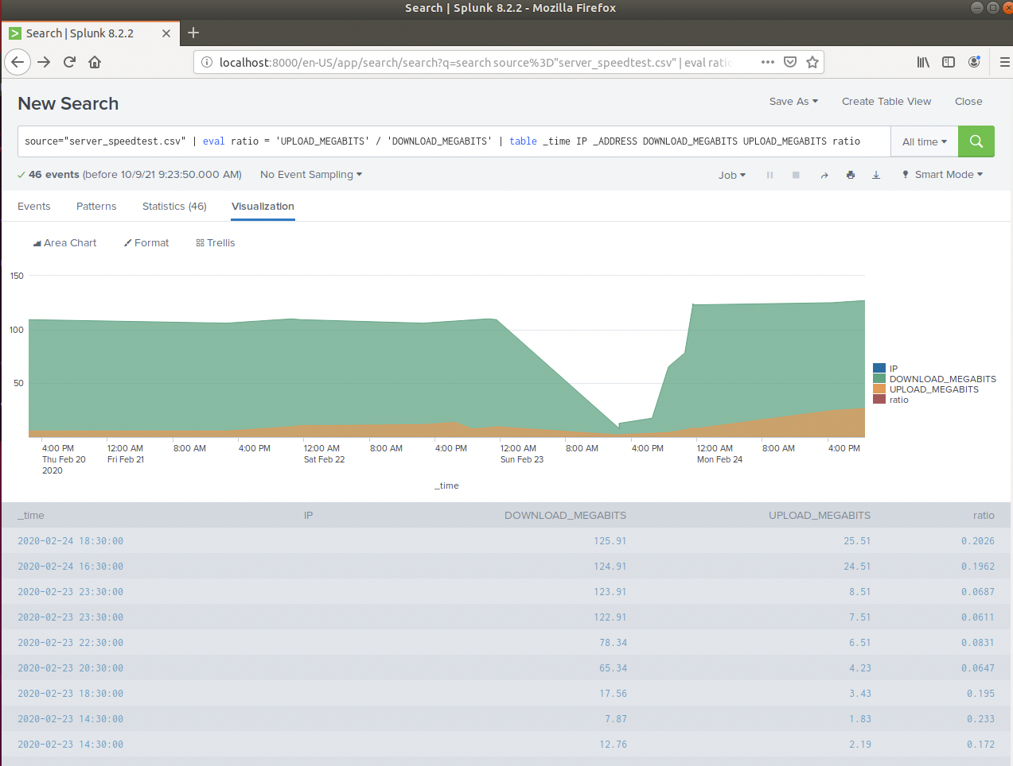

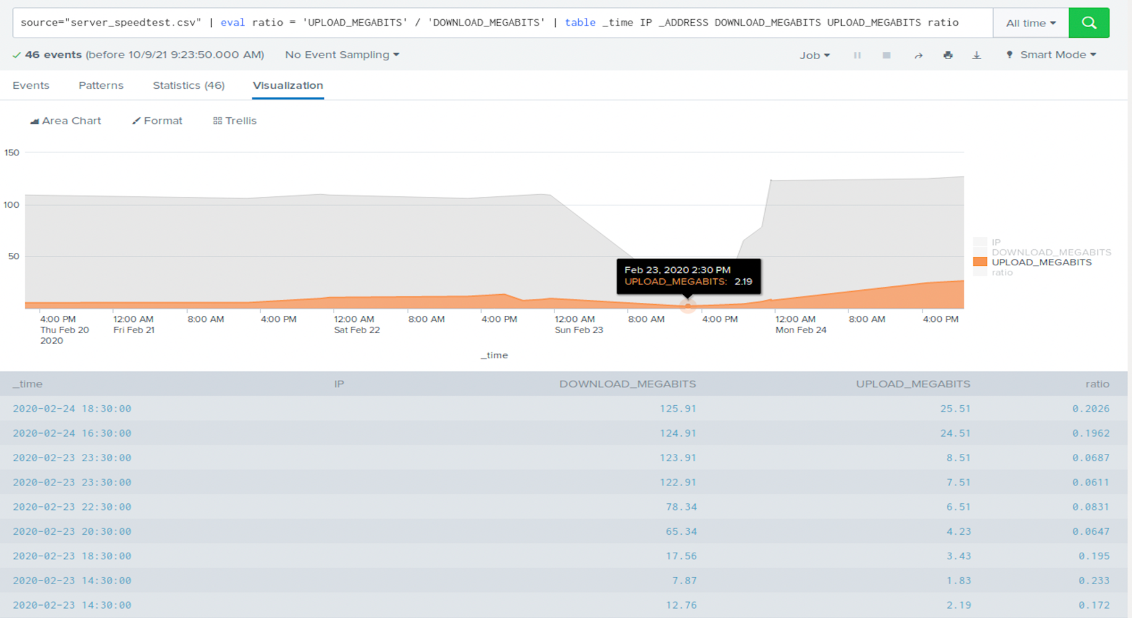



**### Step 2: Are We Vulnerable?**

1. Upload the following file from the Nessus vulnerability scan.

**- [Nessus Scan Results](resources/nessus_logs.csv)**

2. Create a report that shows the `count` of critical vulnerabilities from the customer database server.

- The database server IP is `10.11.36.23`.

**Query Command:** **source="nessus_logs.csv" dest_ip="10.11.36.23" severity=critical | stats count by severity**

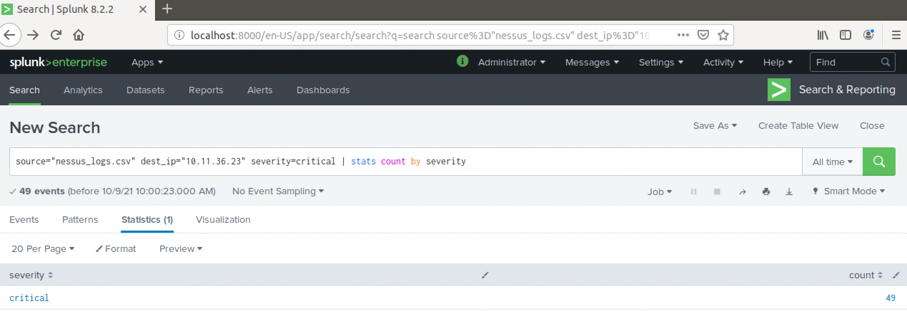

- The field that identifies the level of vulnerabilities is `severity`.

**Query Command: source="nessus_logs.csv" dest_ip="10.11.36.23" | stats count by severity**

**or**

**Query Command: source="nessus_logs.csv" dest_ip="10.11.36.23" | eval CRITICAL=IF(severity="critical", "Critical", "Non-Critical") | stats count by CRITICAL**

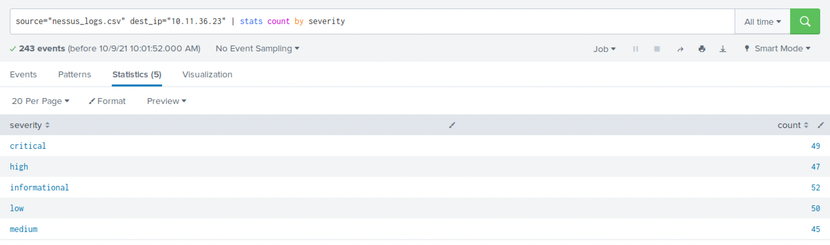

**Comments: -** Below screenshot showing that there are 49 critical database server vulnerabilities, and 194 non-Critical.

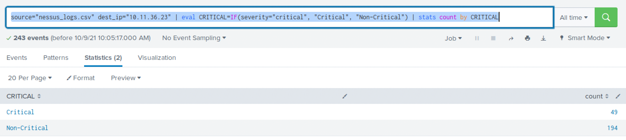



3. Build an alert that monitors every day to see if this server has any critical vulnerabilities. If a vulnerability exists, have an alert emailed to `soc@vandalay.com`.

Submit a screenshot of your report and a screenshot of proof that the alert has been created.

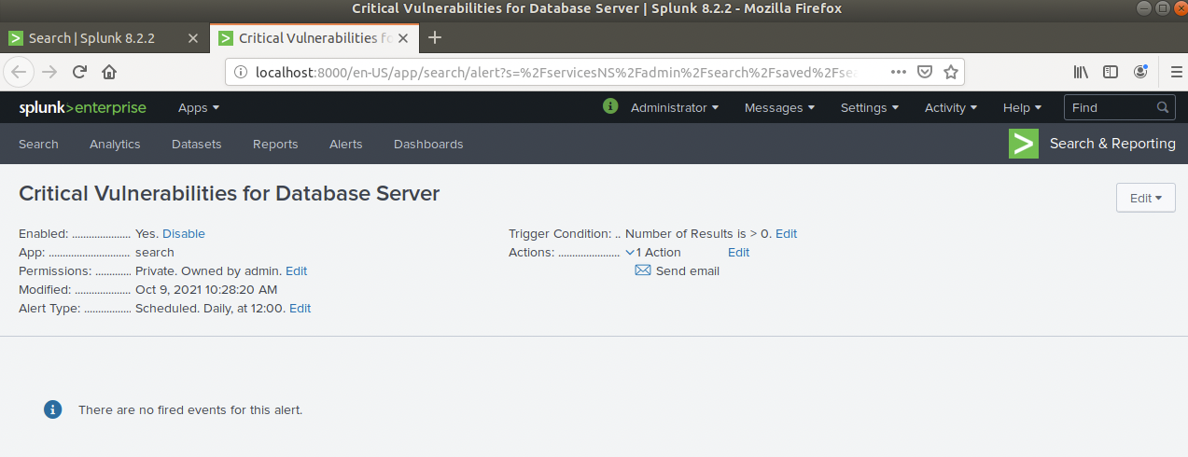

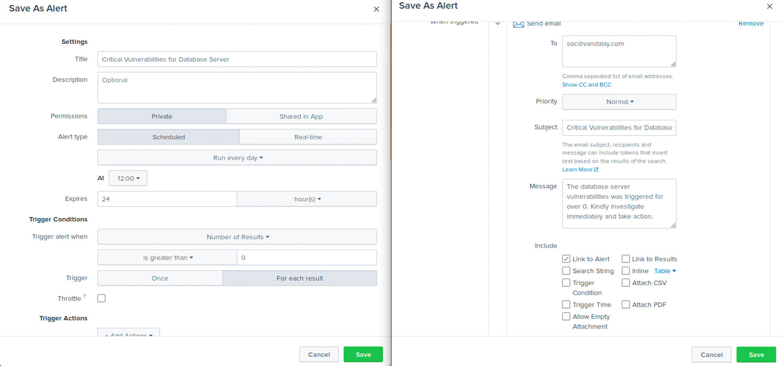



**### Step 3: Drawing the (base)line**

1. Upload the administrator login logs.

**- [Admin Logins](resources/Administrator_logs.csv)**

2. When did the brute force attack occur?

- Hints: - Look for the `name` field to find failed logins.

- Note the attack lasted several hours.

**Answer: -** After checking brute force attack logs, I have found that the attack started after 8.00 but the from 9.00 the attack amount increased so high and it was high until around 14.00, it lasted for almost 6 hours.

**Query Command:** source="Administrator_logs.csv" sourcetype="csv" name="An account failed to log on"

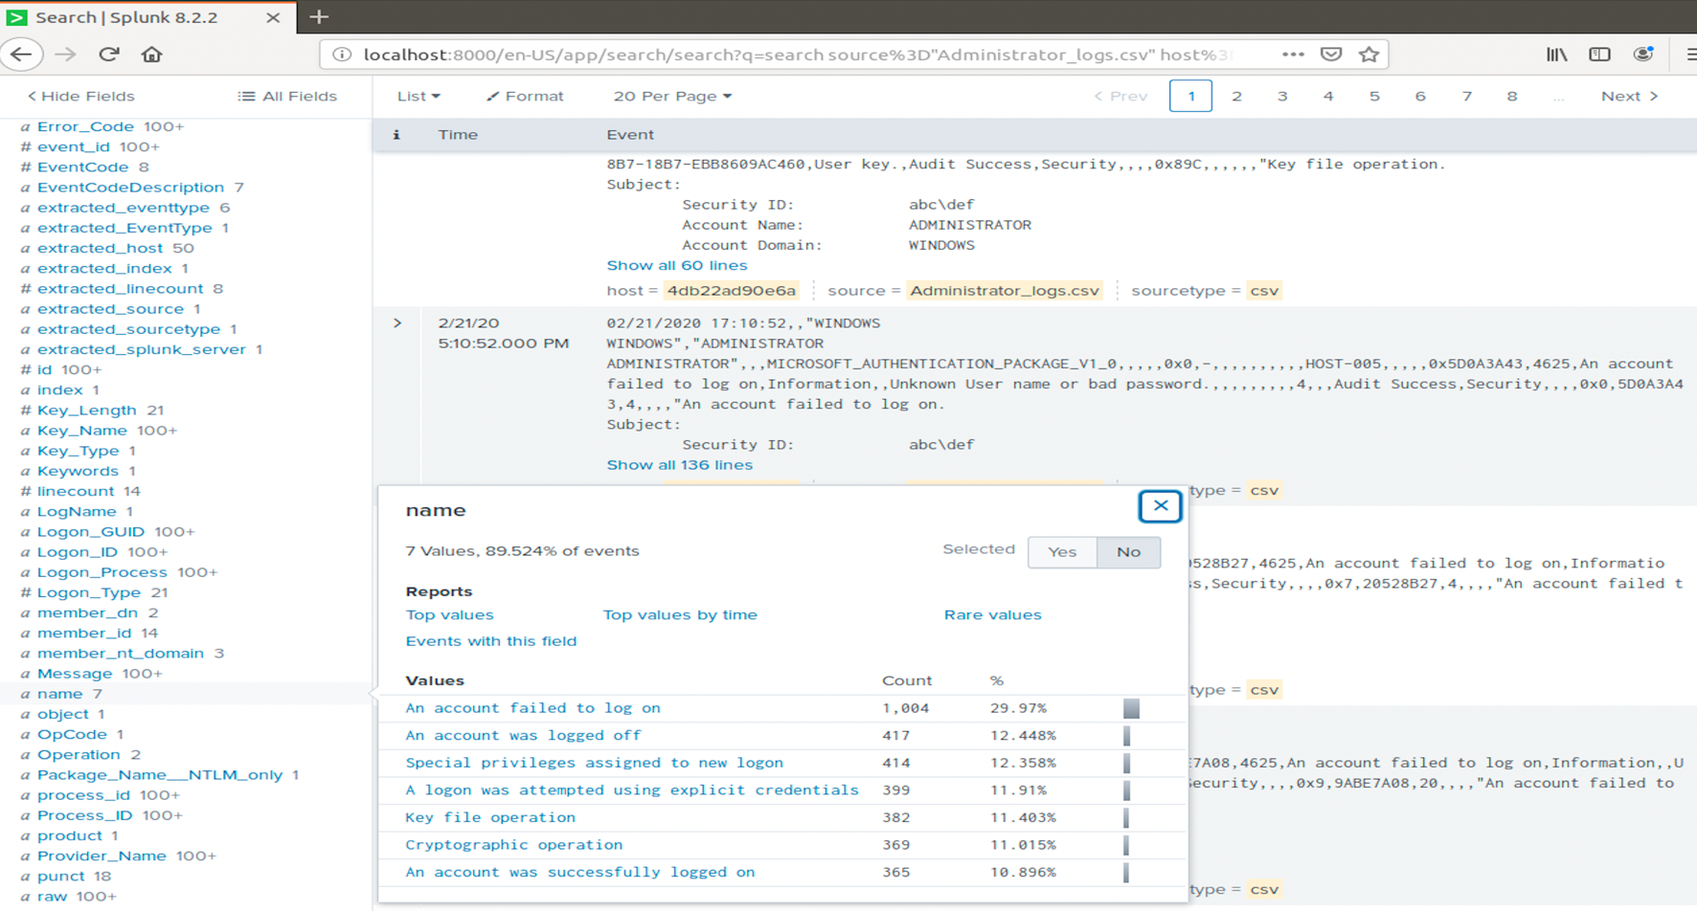

**Starting Time Screenshot**

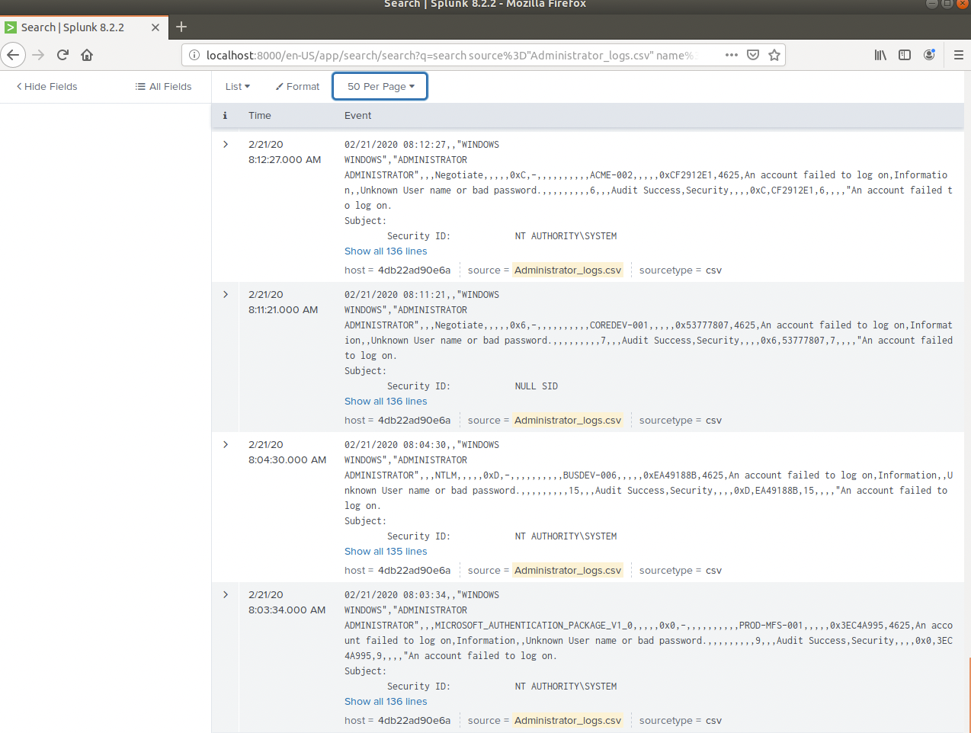

**Ending Time Screenshot**

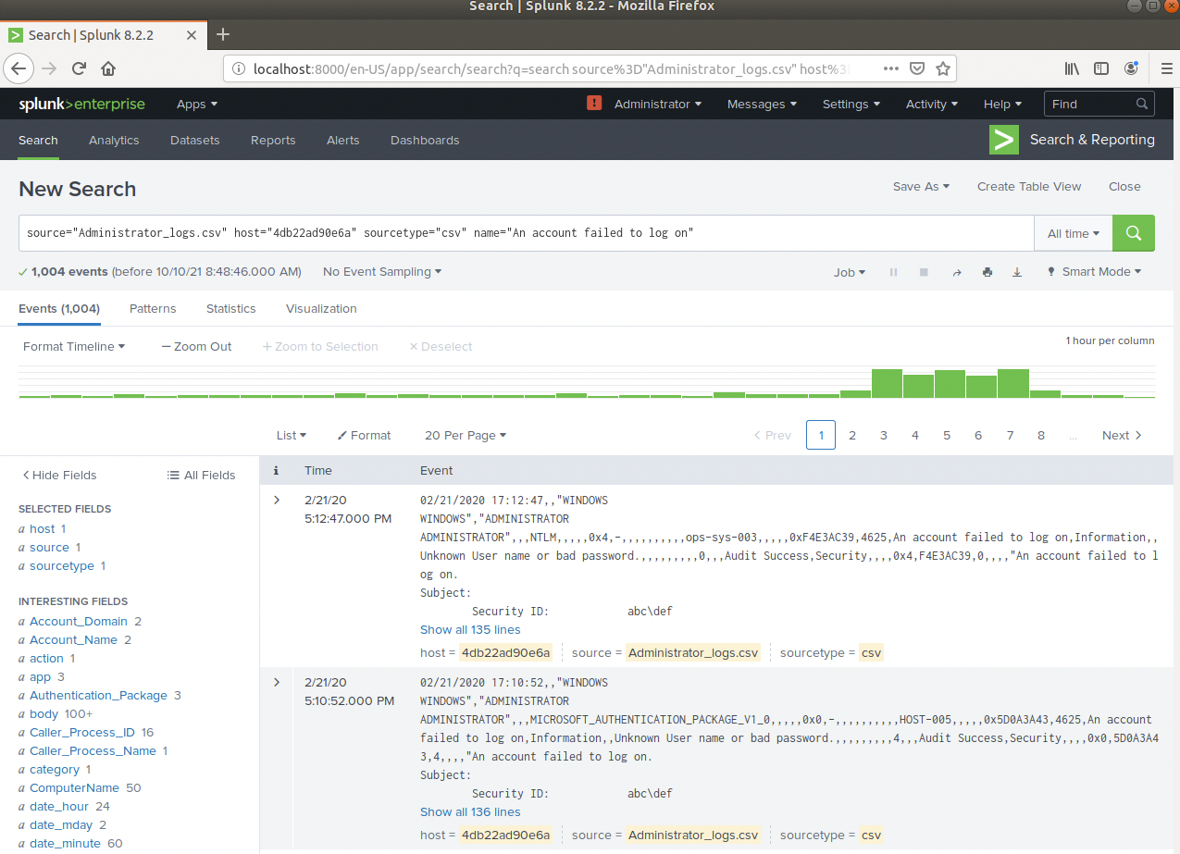



3. Determine a baseline of normal activity and a threshold that would alert if a brute force attack is occurring.

**Answer: -** As per my research all other hours baseline of failed login attempts were less than 20 so I would suggest a baseline of standard failed login attempts should be less than 20 per hours, and if attempts go more than 20 then a report with a threshold of the attacks should pull hourly tigered and alert via email to SOC@vandalay.com.

**Query Command: source="Administrator_logs.csv"| stats count by name | sort -count | eval Bruteforce=if(name="An account failed to log on" AND count>5, "Potential Brute Force", "Not Brute Force")**

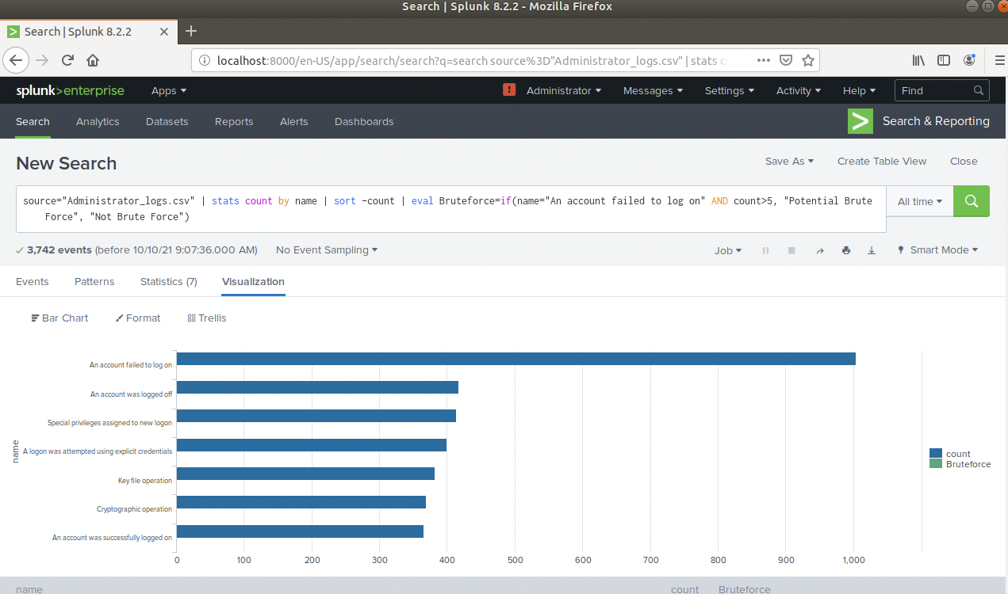

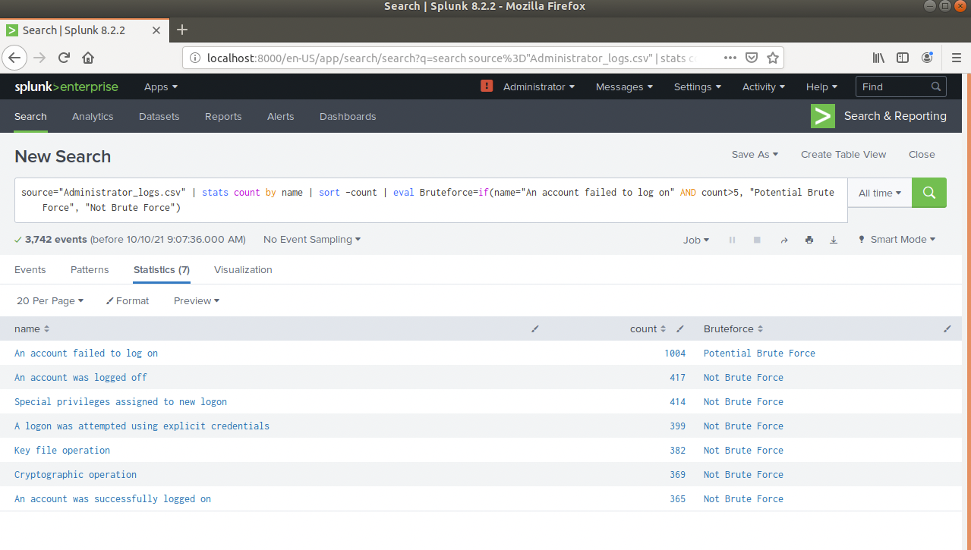

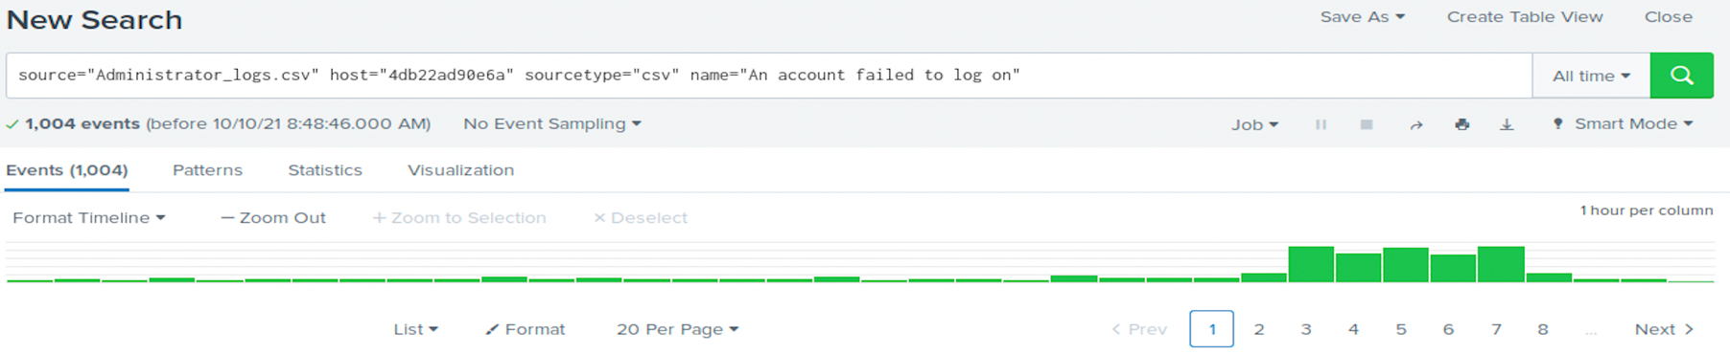



4. Design an alert to check the threshold every hour and email the SOC team at SOC@vandalay.com if triggered.

Submit the answers to the questions about the brute force timing, baseline and threshold. Additionally, provide a screenshot as proof that the alert has been created.

**Alert Proof screenshot**

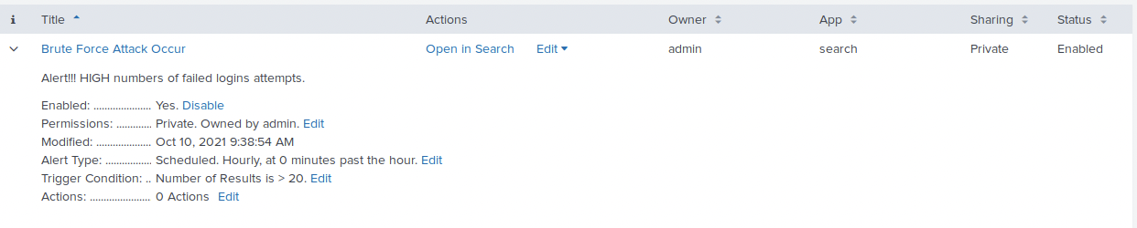

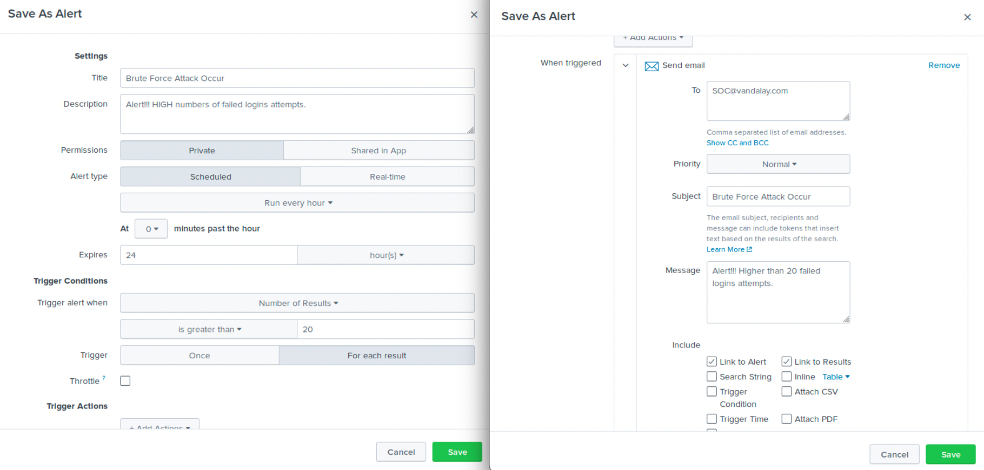

Thank you,

Aziz Somani